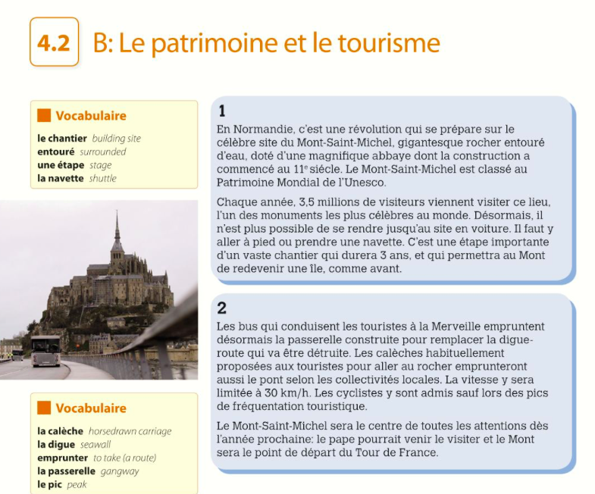
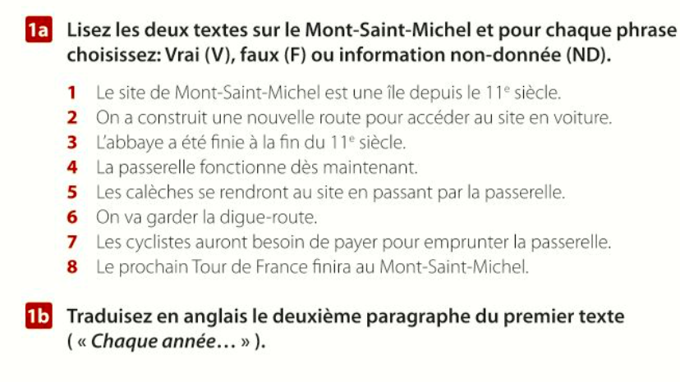

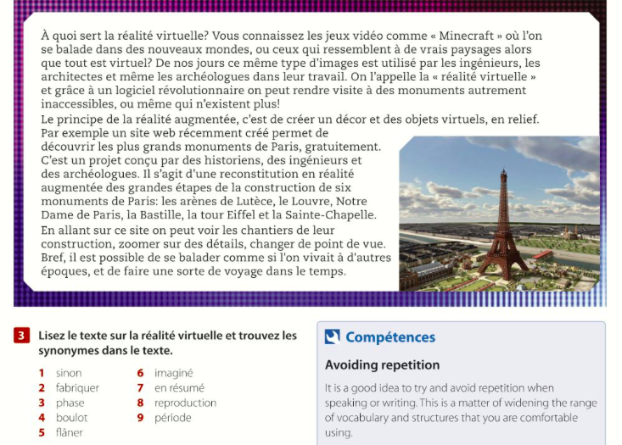

page 77:
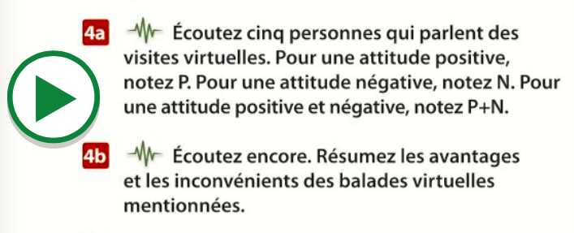

Instructions in English for each task:
1a- Read the 2 texts about Mont St Michel and for each phrase say if it’s true, false or not mentioned
1b- Translate the 2nd paragraph into English
3- Find the synonyms for these words in the text (remember, use wordreference.com if need be)
4a- Listen to the 5 people speaking. Puta P if they have a positive opinion, an N if they have a negative opinion and a P+N for a mixed opinion
4b- Listen again. Summarise the advantages and disadvantages of the ’virtual visits’ mentioned.

