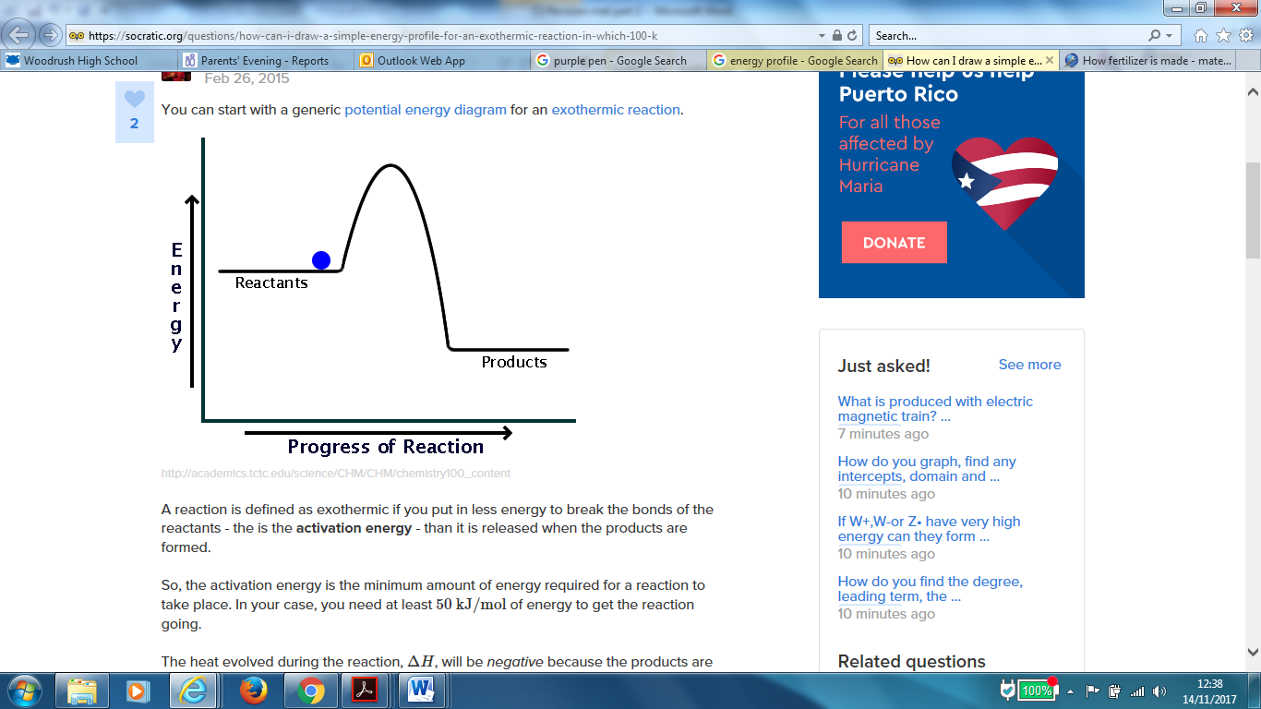

What type of reaction is it when an insoluble salt is formed from soluble salts?

What does the term soluble salt mean?

Which acid does not form H2 gas with a metal?

What type of salts are produced by;

Hydrochloric acid

Sulfuric acid

Nitric acid

Complete the equation;

Acid + metal → ………….carbonate

Complete the equation;

Acid + alkali →

Complete the equation;

Acid + metal →

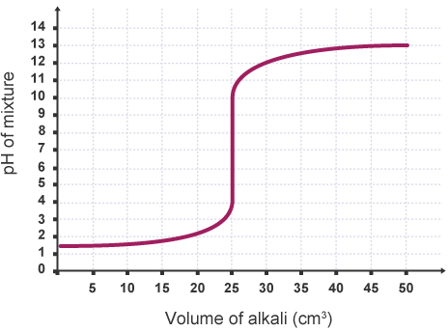

Draw the pH curve for alkali added to acid

Complete the equation;

Acid + base →

The pH of ;

Acids is

Alkalis is

Neutral is

Complete the equation for the ionisation of;

HCl

CH3COOH

The concentration of an acid is a measure of

What is the difference between strong and weak acids?

Calculate the overall energy change for the following reaction;

H-H + Br-Br → 2HBr

H-H = 436kJ/mol, Br-Br = 190kJ/mol, H-Br = 362 kJ/mol

What is the effect on pH of changing the concentration of H+ from 0.1mol/dm3 to 0.001 mol/dm3

In water, what type of ions do;

Acids form

Alkalis form

Suggest 2 ways to measure the pH of a solution 1.

2.

In chemical reactions reactant bonds are broken and new bonds in product formed.

Bond breaking is exothermic/endothermic

Bond making is exothermic /endothermic

Label the activation energy and the overall energy change

Draw the energy profile of an endothermic reaction

Overall energy change

is positive for exothermic/endothermic reactions

is negative for exothermic/endothermic reactions

Complete the following equation;

Overall energy = change

Draw the energy profile of an exothermic reaction