What are the functions of oestrogen and progesterone?

Which two female hormones are released from the ovaries?

Which female hormones are released from the pituitary gland?

Using the chart below, describe and explain the following changes over the menstrual cycle:

- The thickness of the lining of the uterus - The changes which cause the release of an egg

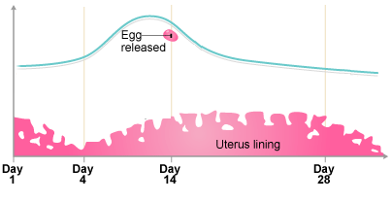

**Complete all questions as a minimum amount of revision.**

When and why does the body release adrenaline?

How does adrenaline affect the following organs?

**The Heart:**

**The liver:**

**The Brain:**

**B3 Revision Sheet**

What is the name of the male sex hormone? What is its function?

What is a hormone?

What is the name of the system of glands which release hormones?

What is the function of thyroxine hormone?

How are the levels of thyroxine regulated?

Explain how a nerve impulse crosses the synapse:

Complete this flow chart to show the path of a nervous impulse:

Stimulus 🡪 Sensory receptor 🡪

What are the 2 parts of the central nervous system?

What makes up the peripheral nervous system?

Explain how a reflex action is different to a voluntary action (Think about the parts of the nervous system that are involved)

Explain how the body responds when blood-glucose levels are too low. Use the following key words:

**Glucagon, pancreas, liver, glycogen, glucose, increase, blood, release.**

Pick 2 hormonal and 2 non-hormonal contraceptive methods. For each method, briefly explain how they work and give an advantage and disadvantage of using them:

What is the cause of type 1 diabetes? How can it be treated?

What is the cause of type 2 diabetes? Why isn’t there a treatment for this disease?

Quick fire questions

1. What is the name of the hormone which reduces blood-glucose levels when they are too high?

2. What term means ‘maintaining a constant internal environment in the body’?

3. Which medical treatment involves fertilising eggs in a lab, and implanting them into the female womb?

4. What are the only contraceptives which provide protection against sexually transmitted infections?

5. What is the name of the disease where people are unable to regulate blood-glucose levels?