The Duke of Edinburgh’s Bronze Award


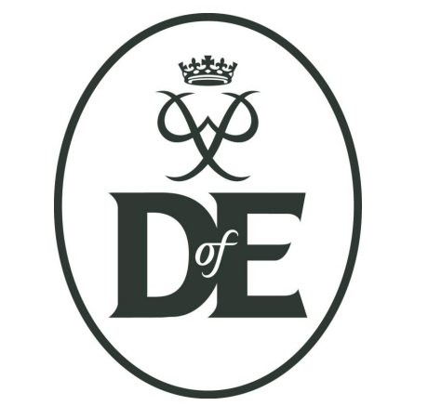

Year 10 Application pack

About the Duke of Edinburgh award
The award requires those taking part to complete 4 sections:
1) Skill (learning a skill at least once a week)
2) Physical (participating in a physical activity at least once a week)
3) Volunteering (being involved in an activity that benefits others once a week)
4) Expedition (completing a training and assessed 2 day hike with an overnight camp)

The Skill, Physical and Volunteer sections all must be attended once a week.
Two of these sections are to be undertaken and completed for three months and one for six months. Students will be assisted in their selection of appropriate activities and monitored by teachers throughout the delivery of the award programme. However, completion of these sections will primarily be the responsibility of the students taking part.

Students will take part in a training walk, a practice expedition and an assessed expedition in the spring of 2019. Completion of the award requires commitment from participants not only to complete their chosen activities but also to the on-going training. Therefore all students taking part will be asked to attend the scheduled extra-curricular sessions and the scheduled sessions to complete the expedition section.

To ensure that all participants receive a quality experience whilst studying for the Duke of Edinburgh’s Award, places on the award will be offered to year 10 students only and limited places are available. Interest in the Award last year was very high and to ensure that participants are fairly chosen a rigorous selection process is used. We ask that students complete these forms and submit returns to student services no later than Monday 12th November.

For more information please see Miss Capaldi or visit the Duke of Edinburgh website.

Please complete this form and the personal statement section and return it to student services no later than Monday 12th November 2018
Student Name: …………………...............................………….. Form …..............…
Why do you want to take part in the Duke of Edinburgh’s Award? ......................................................................................................................................................................................................................................................................................................................................................................................................... ....... ..........................................................................................................................................................................................................................................................................
Describe your characteristics that make you a good candidate for the Duke of Edinburgh’s Award. ......................................................................................................................................................................................................................................................................................................................................................................................................... ....... ..........................................................................................................................................................................................................................................................................
What clubs/extracurricular activities or responsibilities do you currently take part in within school?
Name of club/responsibility: .................................
Description:..................................................................................................................................................................................................................................................................................................................................................................... ............ ....... ......................................................................................................................................
Name of club/responsibility: .................................
Description:............................................................................................................................................................................................................................................................................................................................................................. ..................... ....... ..........................................................................................................................................................................................................................................................................What volunteering/clubs/musical instruments/ sports/ other, do you take part in outside of school? ............................................................................................................................................. ......................................... ................... ............ ............ ............ ............ ............
Name of club/responsibility: .................................Description:.......................................................... ................................................................................................................................................................................. ....................................................................................................... ..............................
Name of club/responsibility: ................................. Description:........................................................................................................................................................................ .........................................................................................................................
Do you have any previous walking or camping experience? If so please give details: ..............................................................................................................................................................................................................................................................................................................................................................................................................................................................................................................................................................................................................................................................................................

Personal statement
Please provide a short statement (no more than 1 page of A4) explaining what makes you a good candidate to take part in the Bronze Duke of Edinburgh’s Award at Woodrush High School.
The statement should be written or typed onto a separate piece of A4 paper and attached to the back of this application form.
Your personal statement should include:
• An introduction to yourself
• Your interests and what you are already involved in, both inside and outside of school i.e roles in and around school; prefect, football club, helping out at open evening, school play etc
• Why you think you would be an excellent candidate for the Duke of Edinburgh’s Award at Woodrush
• What you could bring to the Duke of Edinburgh’s Award at Woodrush and why this makes you a good candidate. i.e teamwork, leadership, problem solving skills

